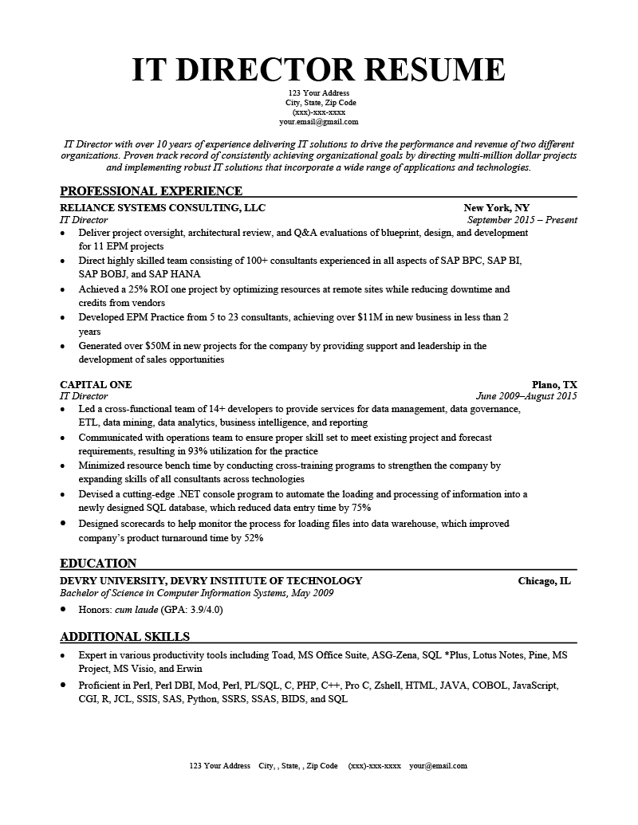
IT DIRECTOR RESUME
123 Your Address City, State, Zip Code (XXX)-XXX-XXXX your.email@gmail.com
IT Director with over 10 years of experience delivering IT solutions to drive the performance and revenue of two different organizations. Proven track record of consistently achieving organizational goals by directing multi-million dollar projects and implementing robust IT solutions that incorporate a wide range of applications and technologies.
PROFESSIONAL EXPERIENCE
RELIANCE SYSTEMS CONSULTING, LLC IT Director
New York, NY September 2015 - Present
• Deliver project oversight, architectural review, and Q&A evaluations of blueprint, design, and development for 11 EPM projects
•
Direct highly skilled team consisting of 100+ consultants experienced in all aspects of SAP BPC, SAP BI, SAP BOBJ, and SAP HANA
·
•
Achieved a 25% ROI one project by optimizing resources at remote sites while reducing downtime and credits from vendors
Developed EPM Practice from 5 to 23 consultants, achieving over $11M in new business in less than 2 years
• Generated over $50M in new projects for the company by providing support and leadership in the development of sales opportunities
CAPITAL ONE
IT Director
Plano, TX
June 2009-August 2015
• Led a cross-functional team of 14+ developers to provide services for data management, data governance, ETL, data mining, data analytics, business intelligence, and reporting
•
Communicated with operations team to ensure proper skill set to meet existing project and forecast requirements, resulting in 93% utilization for the practice
• Minimized resource bench time by conducting cross-training programs to strengthen the company by expanding skills of all consultants across technologies
• Devised a cutting-edge .NET console program to automate the loading and processing of information into a newly designed SQL database, which reduced data entry time by 75%
• Designed scorecards to help monitor the process for loading files into data warehouse, which improved company's product turnaround time by 52%
EDUCATION
DEVRY UNIVERSITY, DEVRY INSTITUTE OF TECHNOLOGY
Bachelor of Science in Computer Information Systems, May 2009
⚫ Honors: cum laude (GPA: 3.9/4.0)
ADDITIONAL SKILLS
Chicago, IL
• Expert in various productivity tools including Toad, MS Office Suite, ASG-Zena, SQL *Plus, Lotus Notes, Pine, MS Project, MS Visio, and Erwin
• Proficient in Perl, Perl DBI, Mod, Perl, PL/SQL, C, PHP, C++, Pro C, Zshell, HTML, JAVA, COBOL, JavaScript, CGI, R, JCL, SSIS, SAS, Python, SSRS, SSAS, BIDS, and SQL
123 Your Address City,, State, Zip Code (XXX)-XXX-XXXX your@email.com

